Crazy AI Features of Apple MacBook Neo
With the release of the Ai Features of apple MacBook neo, high-end smart technology is finally reaching everyone at a price that makes sense. Users worldwide are very much attracted to this device as it released and it has a lot of ai features integrated into it.
What is the Purpose of the MacBook Neo?
The intent of this article is to show you exactly how the Ai Features of apple MacBook neo work and why they are so different from anything else in this price bracket. Usually, "budget" means "slow," but Apple is using its latest iPhone chip to give this laptop a massive brain. We want to help you understand if these smart tools will actually make your life easier.

AI Features of Apple MacBook Neo
When you open the Ai Features of apple MacBook neo, you are greeted by macOS Tahoe and the full suite of Apple Intelligence. Even though it starts at just $599, it doesn't hold back on the "magic" stuff.

Feature | What It Does for You
Writing Tools | Rewrites, proofreads, and summarizes text in any app.
Clean Up | Removes unwanted people or objects from your photos.
Image Playground | Creates original images and sketches based on your words.
Siri with Awareness | Siri now knows what is on your screen and can help accordingly.
Live Translation | Provides real-time captions for video calls and audio.
Priority Mail | Automatically puts your most urgent emails at the top of the list.
Genmoji | Lets you create custom emojis that look like your friends.
Smart Reply | Suggests perfect, context-aware answers to messages.
Notification Summaries | Condenses long group chats into a single short paragraph.
Natural Search | Find specific photos just by describing what is in them.

Smarter Writing and Communication
The Ai Features of apple MacBook neo include built-in Writing Tools. Imagine you are writing a email to a company. These tools can help you to rewrite your text to sound professional and friendly with one click. This feature will save you time and make the mail more professional and appealing.
- Proofreading: It can check for grammar errors and suggests better words and punctuation.
- Summarizing: Instead of reading whole mail it can summarize the whole content into 3 bullet points.
- Smart Reply: In the Mail app, it will suggest quick and context-aware answers to your messages.
Visual and Creative Intelligence
Creating art and fixing photos used to require expensive software. Now, the Ai Features of apple MacBook neo bring these tools to your desktop for free.
- Image Playground: You can create fun, original images just by typing a description in a single prompt.
- Clean Up in Photos: If a stranger walks into the background of your perfect vacation photo, you can just tap them, and the AI makes them disappear. This is one of the best AI features.
- Genmoji: You can create your own custom emojis that look like your friends or family. This customized emoji generator app is one of the most required feature.

Performance and AI Hardware
The secret behind the Ai Features of apple MacBook neo is the A18 Pro chip. This is the first time a Mac has used an iPhone chip, and it is specifically built for AI.
Feature | MacBook Neo Capability
Neural Engine | 16-Core (Optimized for AI)
Siri | New glowing edge UI with screen awareness
Privacy | Private Cloud Compute for secure processing
Live Translation | Real-time captions for calls and video

The Ai Features of apple MacBook neo prove that you do not need to spend thousands of dollars to own a "smart" computer. By bringing the power of the A18 Pro chip to a $599 laptop, Apple has made advanced technology accessible to everyone. Whether you are summarizing notes for class or editing photos for social media, the Ai Features of apple MacBook neo provide a smooth and intelligent experience that was once impossible at this price.
Which of these AI tools are you most excited to try?
Do you think Apple's focus on privacy makes their AI better than the competition?
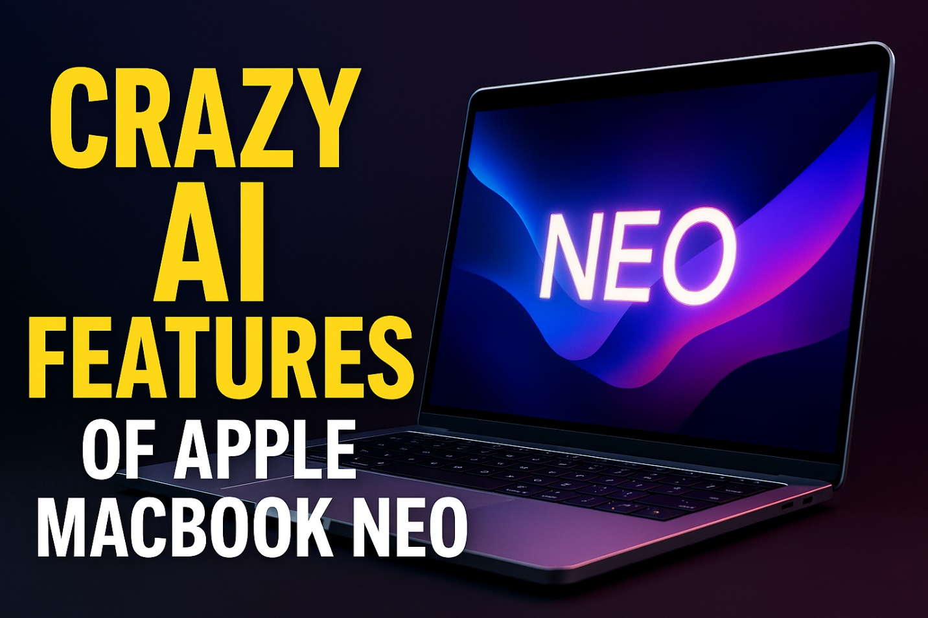
MacBook Neo - Apple

AI Features of Nothing 4a Pro and Nothing Phone 4a
Nothing officially launched the Nothing Phone 4a and the Nothing 4a Pro today, March 5, 2026. Mobiles price of ₹31,999 ($380) for the standard and ₹39,999 ($480) for the Pro. These devices are available immediately on Flipkart and the Nothing website, bringing flagship-level AI features to the mid-range market for the first time. If you thought Nothing was just about transparent backs and flashing lights, these new AI-driven capabilities will completely change how you view your smartphone. It has many Artificial intelligence integrated features.
Many people buy phones based on hardware alone, but the real magic in 2026 is happening within the software and the inbuilt AI features.
Our goal is to help you decide if the Nothing 4a Pro or the Nothing Phone 4a is the right choice for your daily needs.
Innovative AI Features of Nothing 4a Pro and Nothing Phone 4a
Nothing has integrated AI directly into the operating system rather than just offering separate apps. This means the phone learns from you (Your device experience) every day to get faster and more helpful.

List of AI Features of Nothing 4a Pro and Nothing Phone 4a

# | Feature Name | Description | Availability
1 | Essential Voice | Real-time voice-to-text translation for 12+ languages during calls or in-person chats. | Both Models
2 | Ultra Zoom AI | Uses AI reconstruction to keep images sharp at massive 140x digital zoom levels. | Pro Model
3 | AI Eraser | A built-in "magic" tool in the Nothing Gallery to remove people or objects with one tap. | Both Models
4 | TrueLens Engine 4 | Advanced multi-frame AI processing for Ultra XDR photos with lifelike detail. | Both Models
5 | AI Semantic Segmentation | Analyzes 12 layers of an image (hair, skin, sky) to optimize colors and bokeh naturally. | Both Models
6 | Essential Search | An AI-powered universal search that finds files and info across all installed apps. | Both Models
7 | Generative Ringtones | Create unique, synth-style ringtones based on text prompts or your current mood. | Both Models
8 | Adaptive Battery AI | Learns your usage cycles to limit power drain and optimize long-term battery health. | Both Models
9 | Essential Memory | Predicts which apps you will open next to pre-load them into RAM for instant launching. | Both Models
10 | Smart Glyph Cues | AI prioritizes back-panel lighting for "essential" notifications only, reducing screen time. | Both Models

Smart Camera Enhancements
The Nothing 4a Pro features a new "TrueLens Engine 4" which uses AI to fix blurry photos in real-time. If you take a photo of a moving pet or a fast car, the AI fills in the missing details to keep the image sharp. The Pro model also includes "Ultra Zoom AI," which allows you to zoom in 140 times while using software to keep the picture from looking like a blocky mess.
Nothing OS 4.1 Intelligence
The software is where the Nothing Phone 4a really shines. It includes:
- Essential Voice: This tool translates live conversations. You can talk to someone in another language, and the phone displays the translation on the screen instantly.
- Smart Glyph Cues: The lights on the back of the phone now use AI to glow only for your most important contacts, helping you stay off your screen.
- AI Battery Guard: The phone tracks when you go to sleep and adjusts charging speeds to make sure your battery lasts for many years without wearing out.
Comparing the AI Features of Nothing 4a Pro vs Nothing Phone 4a
Feature | Nothing Phone 4a | Nothing 4a Pro
Translation | Standard Text | Real-time Voice & Text
Photo Editing | Object Removal | Advanced Scene Reconstruction
Zoom AI | 50x Digital | 140x Ultra Zoom AI
Glyph AI | Basic Patterns | Advanced Predictive Lighting

Why These AI Features Matter
The AI features of Nothing 4a Pro and Nothing Phone 4a are designed to reduce "digital noise." Instead of giving you more distractions, the AI acts like a personal assistant that filters out what you don't need. For example, the Generative Ringtones feature lets you create your own music just by typing a description of a sound you like.
In conclusion, the Nothing 4a Pro and Nothing Phone 4a offer an incredible balance of style and smart technology. These phones prove that you do not need to spend a fortune to get the latest artificial intelligence tools. Whether you want better photos or a phone that understands your habits, these devices deliver real value.

HP Latest Laptop With AI

If you want to purchase hp latest laptop with ai, then you are looking to a device which can do more than running programs. It understands what you need. It is all about getting a device which will save your time and makes hard tasks easy for yopu. As AI grows, these laptops will only get better, receiving updates that teach them new tricks.
Top 10 HP Latest Laptops With AI
# | Model Name | Key AI Hardware | Best For
1 | HP OmniBook Ultra Flip 14 | Intel Core Ultra 9 (Series 2) | 2-in-1 Versatility & Top Performance
2 | HP OmniBook Ultra 14 | AMD Ryzen AI 300 Series | High-End Content Creation
3 | HP EliteBook Ultra G1q | Snapdragon X Elite | Ultimate Battery Life & Portability
4 | HP Spectre x360 14 (2024/25) | Intel Core Ultra 7 | Premium Everyday Use
5 | HP OmniBook X | Snapdragon X Elite | Student & Remote Work Productivity
6 | HP ZBook Power G11 | Intel Core Ultra + NVIDIA RTX | Engineering & 3D Modeling
7 | HP EliteBook 1040 G11 | Intel Core Ultra 7 | Executive Business & Security
8 | HP ZBook Fury G11 | Intel Core Ultra (vPro) | Desktop-Replacement Workflows
9 | HP ProBook 440 G11 | Intel Core Ultra 5 | Small Business & Budget AI
10 | HP OmniBook 3 15 | AMD Ryzen AI 5 | Entry-Level AI Computing

AI Features Comparison Table
Laptop Name | Top 5 AI Features
HP OmniBook Ultra Flip 14 | 1. 48 TOPS AI Engine  2. 9MP AI Camera High-Res  3. AI Companion Virtual Assistant  4. Poly Camera Pro Effects  5. Smart Lighting Video Adjust
HP OmniBook Ultra 14 | 1. 55 TOPS AMD NPU  2. AI Performance Speed Boost  3. Smart Sense Power Control  4. AI Noise Removal Mic  5. Local AI File Analysis
HP EliteBook Ultra G1q | 1. Qualcomm 45 TOPS NPU  2. Windows Studio Effects Tool  3. AI Proactive Threat Detection  4. Real-time Live Captions Subtitles  5. AI Super Resolution Upscaling
HP Spectre x360 14 | 1. AI Walk Away Lock  2. AI Wake On Approach  3. Screen Distance Alert Warning  4. AI Background Blur Video  5. Intelligent Sensing Audio Tuning
HP OmniBook X | 1. Dedicated Copilot+ Key Access  2. AI Image Creator Tool  3. 28-hour AI Battery Life  4. Secure Local AI Processing  5. Magic Background Camera Effect
HP ZBook Power G11 | 1. AI Driven Power Management  2. NVIDIA RTX AI Graphics  3. Pro-App AI Certification Workflows  4. Smart Cooling Thermal Control  5. AI Noise Suppression Filters
HP EliteBook 1040 G11 | 1. Dynamic Voice Leveling Mic  2. AI Privacy Screen Protection  3. Smart Sense Silent Mode  4. AI Malware Behavioral Analysis  5. Auto Frame Camera Zoom
HP ZBook Fury G11 | 1. Z AI Studio Platform  2. Intelligent Hibernate Battery Save  3. AI Machine Learning Training  4. Dynamic Microphone Gain Tuning  5. Smart Power Distribution Logic
HP ProBook 440 G11 | 1. Intel AI Boost Processing  2. AI Behavioral Security Guard  3. One-Touch Copilot AI Help  4. Poly Studio AI Audio  5. Connected Modern Standby Wake
HP OmniBook 3 15 | 1. Ryzen AI Entry Performance  2. Live Captions Real-time Subtitles  3. AI Enhanced Paint Cocreator  4. Windows Studio Effects Camera  5. Efficient AI Multitasking Flow

Why These AI Features Matter
The hp latest laptop with ai focuses on three main things: privacy, productivity, and peripherals. For example, features like "Walk Away Lock" ensure your data is safe without you touching a button. "AI Noise Removal" makes you sound professional even if you are working from a busy coffee shop.

New Laptops With AI Chips for you should not miss

The wait for a smarter computer is over because new laptops with ai chips are changing everything. These machines are not just faster; they actually learn how you work to save you time and battery life. Major companies like Apple, HP, Lenovo, and Asus have just released their 2026 models, and the results are amazing. You can now find a high-quality AI laptop for an average price of $800 to $1,200, making this futuristic technology affordable for students and professionals alike. Whether you want the new MacBook Air with the M5 chip or a Windows Copilot+ PC, there has never been a better time to upgrade.

These new laptops with ai chips are perfect for taking notes and organizing schedules automatically. Many of these features were once only available on expensive desktops, but now they fit right in your backpack.
Why You Need a Laptop With an AI Chip
The new laptops with ai chips include a third part called a Neural Processing Unit (NPU). This part is a specialist that only handles AI work.
- Better Battery Life: Because the NPU is so efficient, your battery can last up to 20-28 hours.
- Privacy: Your data stays on your laptop instead of being sent to a cloud server.
- Speed: Tasks like searching through your photos or summarizing a long PDF happen instantly.
Top Models and Prices in 2026
Brand | Model | Processor | Starting Price
Apple | MacBook Air M5 | Apple M5 Chip | $999
HP | OmniBook X | Snapdragon X Elite | $1,149
Asus | Vivobook S 14 | Intel Core Ultra 7 | $899
Lenovo | Yoga Slim 7i | Intel Core Ultra 5 | $849

Comparison of New Laptops With AI Chips (2026 Models)
To help you choose, we have gathered ten of the most popular models available right now. Each of these new laptops with ai chips offers unique features designed to make your life easier.
Model Name | AI Processor | Avg. Price | Key AI Features
Apple MacBook Air 13 (2026) | Apple M5 (Neural Engine) | $1,199 | Advanced Apple Intelligence, local LLM support
Microsoft Surface Laptop 7 | Snapdragon X Elite 2 | $999 | Recall, Cocreator in Paint, 28-hour battery
Asus Zenbook A16 (2026) | Snapdragon X2 Elite | $1,299 | 80 TOPS NPU, Omni Virtual Assistant
HP OmniBook X Flip | Intel Core Ultra 7 (S3) | $1,349 | 2-in-1 design, Windows Studio Effects
Lenovo Yoga Slim 7i Aura | Intel Core Ultra 5 (S3) | $1,100 | Smart Share, context-aware battery modes
Acer Swift Go 14 AI | Snapdragon X Plus | $850 | Live Captions, high-efficiency AI multitasking
Asus TUF Gaming A14 | AMD Ryzen AI Max 392 | $1,599 | 50 TOPS, AI-enhanced gaming frame rates
Dell Inspiron 14 Plus | Intel Core Ultra 7 | $1,050 | Automatic noise cancellation, smart security
SAMSUNG Galaxy Book5 360 | Intel Core Ultra 7 | $1,250 | Phone-to-PC AI link, Circle to Search
Lenovo IdeaPad Slim 3x | Qualcomm Snapdragon X | $799 | Budget-friendly NPU, instant wake/sleep

